G. Fun Facts
- Gecko Feet: Geckos can walk on walls because of van der Waals forces (instantaneous dipole-induced dipole). Millions of tiny hairs on their feet create enough surface area for these weak forces to hold them up.
- Water's Superpower: If ice didn't float (due to H-bonding making it less dense), lakes would freeze from the bottom up, killing all marine life. H-bonding literally saves the fish!
- DNA Zipper: The two strands of your DNA are held together by Hydrogen bonds. A pairs with T (2 bonds), G pairs with C (3 bonds). It's strong enough to hold the code, but weak enough to "unzip" for replication.
- Oxygen is Magnetic: Liquid oxygen is attracted to a strong magnet. You can actually suspend a drop of liquid oxygen between magnetic poles!
- Glass is a Liquid? No, that's a myth. But glass is an "amorphous solid," meaning its molecules are arranged randomly like a liquid, but frozen in place.
- Diamond vs. Graphite: Both are pure carbon. Diamond is $sp^{3}$ (hardest natural material). Graphite is $sp^{2}$ (slippery, used in pencils). The only difference is the hybridization!
- Explosive Nitrogen: $N_{2}$ has a triple bond, making it incredibly stable. Explosives like TNT work by releasing $N_{2}$ gas rapidly. The energy released comes from forming these superstrong triple bonds.
- Teflon: The $C-F$ bond is one of the strongest single bonds in organic chemistry. That's why Teflon pans don't react with your food (or anything else).
- Super-glue: Cyanoacrylate (super glue) polymerizes instantly upon contact with trace amounts of water (hydroxide ions) present on almost all surfaces.
Shape Matters: The difference between a medicine and a poison is often just the 3D shape (chirality) of the molecule, determined by its bonding.
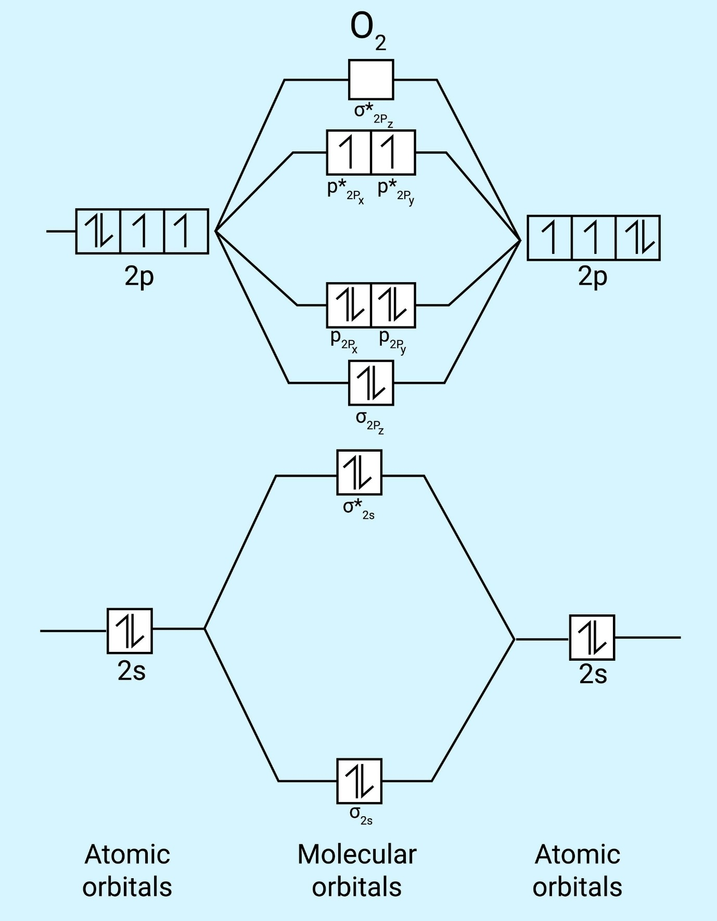
Unit 5: Chemical Thermodynamics

